ORB is a free algorithm developed by OpenCV labs as a fusion of FAST and BRIEF with various modifications and compromises to enhance performance

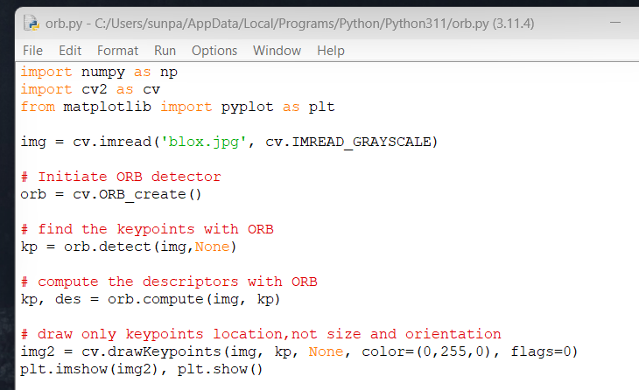

Code to create and compute orb objects

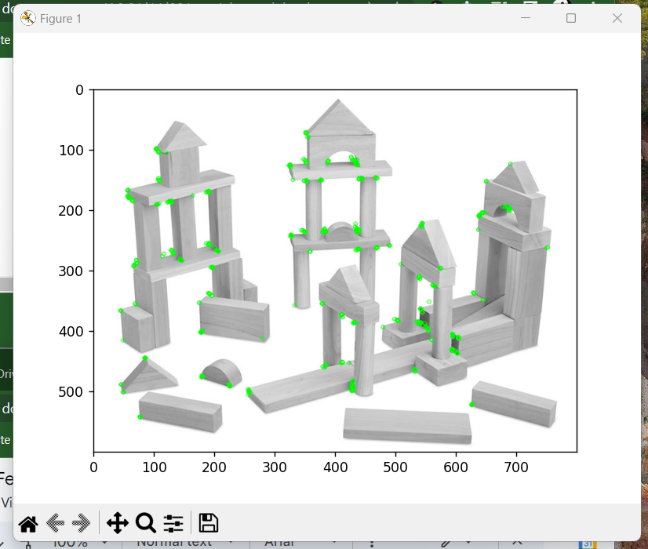

Relatively quick, however one may notice various “features” not detected, or thrown out by the algorithm